**The Ice Watch Manual**

Jennifer Hutchings1, Jennifer Delamere2, Petra Heil3,4

1 College of Earth Ocean and Atmospheric Sciences, Oregon State University,

++1 541 7373 4453, [jhutchings@oregonstate.edu](mailto:jhutchings@oregonstate.edu)

2 Geographic Information Network of Alaska, University of Alaska Fairbanks.

3. Australian Antarctic Division

4. The University of Tasmania.

**UPDATE 2020/02/03 Transfer to Met Norway**

On 19th Nov 2019 the Icewatch system was transferred to the Norwegian Meteorological Institute ([https://met.no](https://met.no/)). This manual has been updated to reflect this change. If you have questions regarding the Icewatch system you should now contact [icewatch@met.no](mailto:icewatch@met.no) or visit [https://icewatch.met.no](https://icewatch.met.no/). Specific enquiries about this document can be made to the original authors listed above.

**DRAFT 2018/06/30 for ASSIST v4.1**

We value your feedback and comments on this manual. Ice Watch is a community effort and if you would like to help improve the manual, please contact Jenny Hutchings ([jhutchings@coas.oregonstate.edu](mailto:jhutchings@coas.oregonstate.edu)). In particular we would value contributions of photographs that show scale of particular ice types, floe sizes, open water type et cetera. Your contributions will be acknowledged.

Photographs needed:

Ice with sediment

Sastrugi, and other snow types. Example of granular layer due to summer melt.

Photographic guide to melt.

Cloud types (Arctic specific).

This manual will be published as a technical document through the University of Alaska Fairbanks once it is finalized.

**Contents**

**1. Introduction 3**

**2. Observing sea ice from ships 3**

**3. Archiving ice watch data 29**

**Acknowledgements 30**

**Appendix A ASSIST observation code digest 31**

**Appendix B Differences between ASPeCt and ASSIST 42**

**Appendix C ASSIST installation guide 45**

**Appendix D Data saving and archiving guide 51**

**Appendix E Trouble shooting 53**

**Appendix F Known bugs 54**

**References 55**

**The Ice Watch Manual**

**1. Introduction**

Visual observations of ice from airplane or ship are an integral part of sea ice monitoring for operational and research support. These observations provide information about sea ice morphology that is not obtainable or ambiguous in remotely sensed data. Ice Watch is a program coordinating visual observations of sea ice conducted from ships in the northern hemisphere. Following from efforts to standardize sea ice observations in the Antarctic (Worby and Alison, 1999), Ice Watch provides observation protocols and software to aid in the standardization of ship-based visual sea ice observations in the Northern hemisphere and globally. Ice Watch codes are fully compatible with ASPeCt codes, such that Ice Watch can be used in the southern hemisphere.

Observational data can be recorded with a software tool, the ASSIST, provided by the Ice Watch program. This manual describes how to conduct a sea ice watch from a ship, how to record the data and archive with the Ice Watch program.

Archived data is served in a variety of formats including shape files and CSV. CSV output is provided with variable names described in Appendix A of this manual. The ***ASPeCt v3 CSV*** format is also provided, which does not include all the data fields available in ASSIST. The ***SIGRID-3*** format (JCOMM 2014), standard for ice charting, can be selected.

Please read section 2 for guidance on how to perform an ice watch and record data in ASSIST. Section 3 describes how to archive your data with the Ice Watch program.

**2. Observing Sea Ice from Ships**

The optimal location to observe sea ice on a ship is often the bridge or an upper deck on the ship with a 360o view. It is preferable to perform an ice watch hourly throughout the day and night, however ASSIST and Ice Watch are flexible in receiving data collected on different time intervals. Observations should only be recorded when the ship is travelling and for the first observational period when on station. A watch can consist of multiple people observing on a schedule. In this case ***the watch should organize for observers to cross compare observations*** at the same time. ***New observers should be paired with experienced observers for training***. This is to ensure consistency in observations across the cruise period. A watch leader may be assigned who is responsible for checking data consistency and quality, and will manage the ice watch. If it is desirable to work from the ships bridge, the watch leader should approach the captain to obtain permission to enter the bridge routinely and observe the ships RADAR and navigational data.

The standard procedure for an ice watch is to make an observation every hour, on the hour, when the ship is in motion. Observations should not be recorded when the ship has not moved with in the ice pack, and the same ice would be observed in two observations. It is recommended the ship moves 3 nautical miles, under it’s own power not drifting with the pack, between observations.

The ice is viewed within **1 nautical mile** (nm) from the ship during a **10 minute** observation period that is normally performed on the ship’s bridge. In this manual we guide you through the methodology to conduct each 10 minute observation, following the interface of the data entry software.

***How to identify a 1nm region around the ship***

The ship’s RADAR will have a display screen on the bridge. By orientating yourself to features in the ice pack that are apparent on the RADAR display you can determine distances in your field of view. With practice you will be able to train your eye to these distances. In figure 1 there are areas of ice (ice has topography and roughness that reflects the RADAR signal and appears bright on the display). In this image flat areas are open water, and the shape of these can be lined up with your view out the bridge window.

Often talking to Officers on the bridge, when they are not busy, can identifying targets on the RADAR screen can help you locate the 1nm area around the ship.

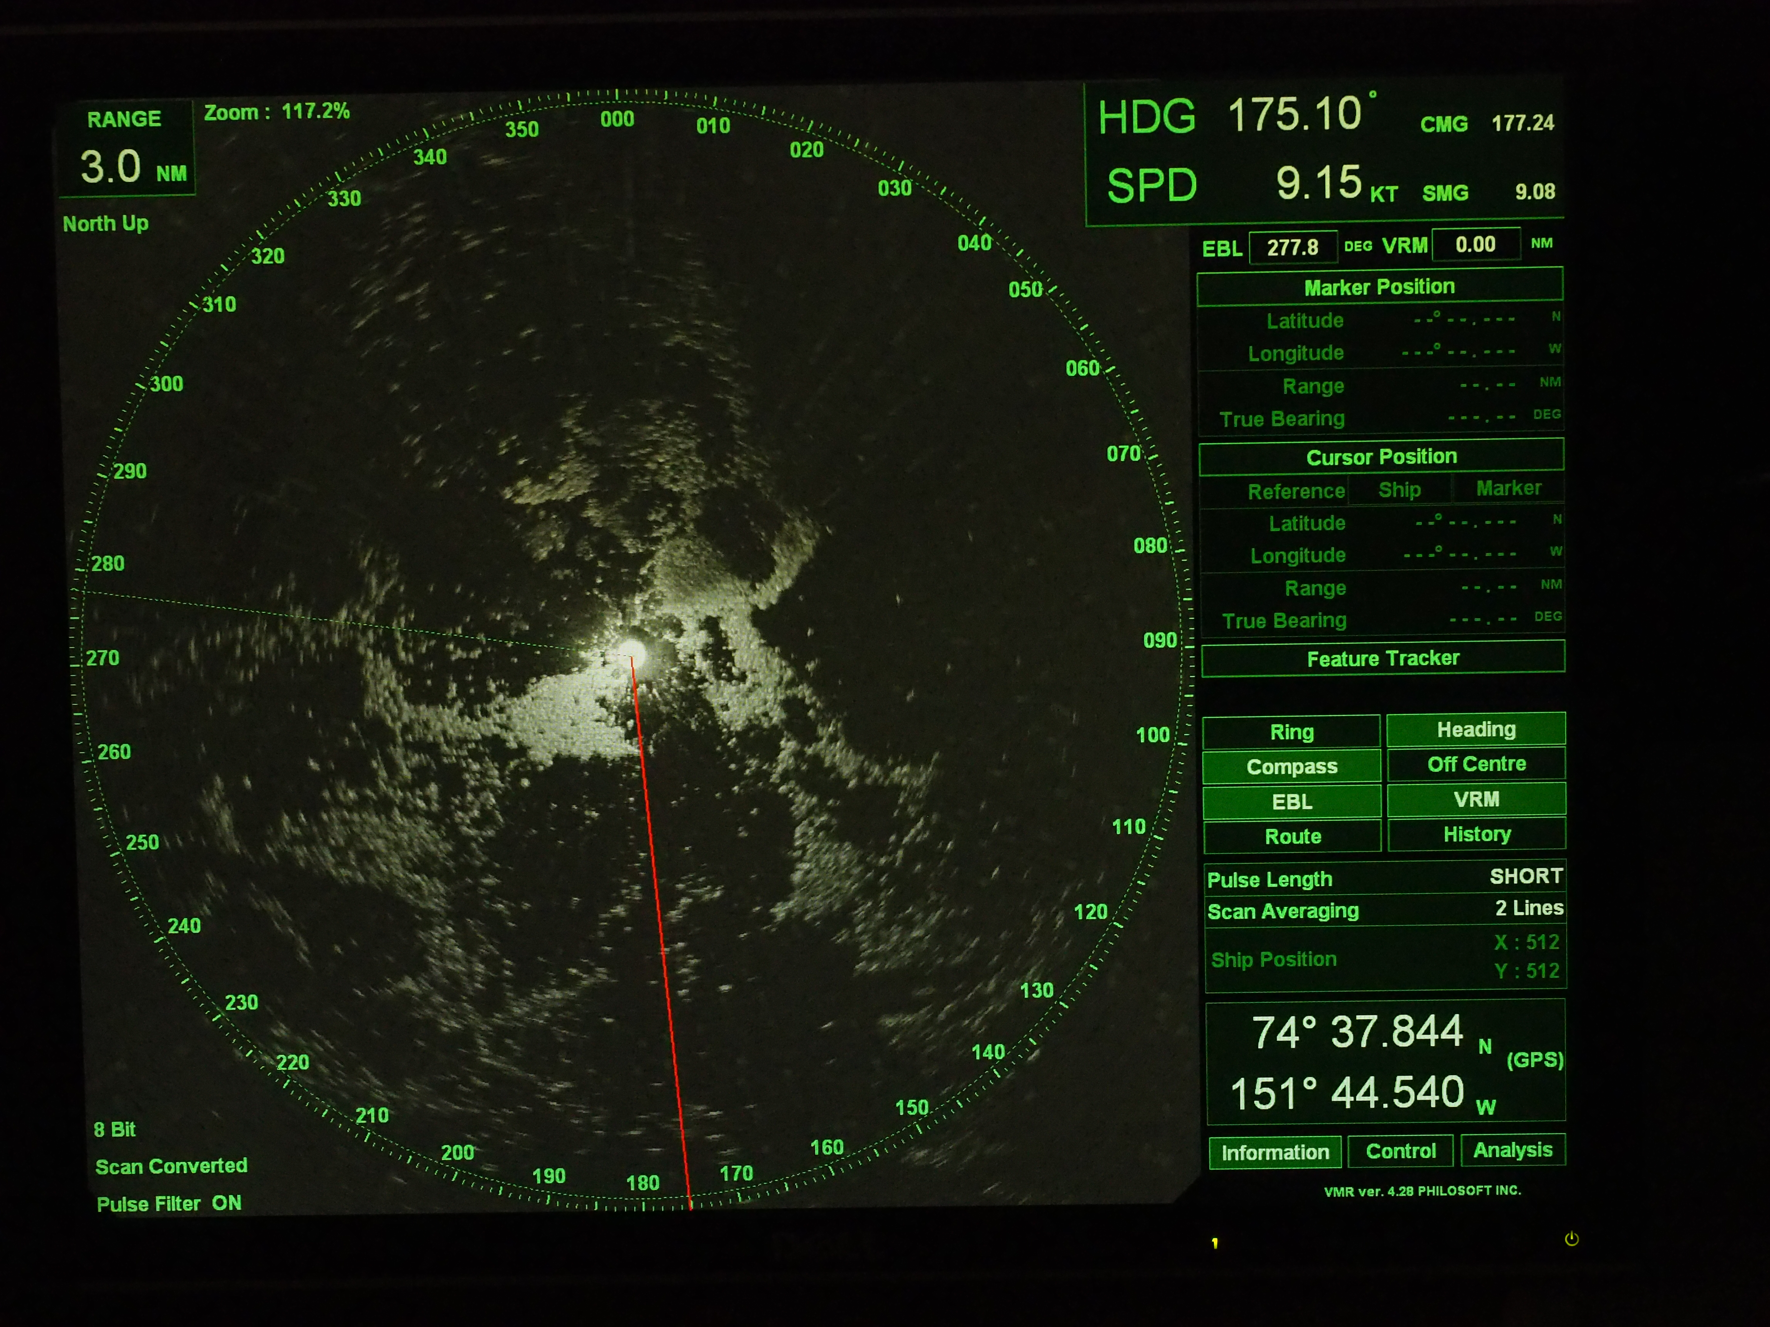

Figure 1: Typical RADAR display. This display is set to show 3nm about the ship.

***2.1 Software to record bridge observations***

The Arctic ship-borne sea ice standardization tool (ASSIST) is a stand-alone web interface that guides an observer through recording visually estimated properties of the sea ice. It has an intuitive interface and runs on Windows, Mac and Linux platforms. To install assist, download the latest version from icewatch.met.no and follow the directions in appendix B.

The philosophy of ASSIST is to guide users through the observation process, and help ensure standardized data is recorded accurately and consistently.

***2.2 Conducting an Ice Watch Observation***

Ice Watch observations are organized in the ASSIST data input interface into a series of tabs: General, Ice, Meteorology, Photos and Comments. In the description of the observation codes below we present the data in tables associated with each tab. Data is output in comma separated value, CSV, format and the header for each data column is given in appendix A and the file ASSISTv4_CheatSheets.pdf provided with the ASSIST installation package.

At the start of a cruise, start a fresh copy of ASSIST or create a new cruise database on startup of ASSIST. All cruise data should be recorded in a single database. Please see the installation guide in appendix B for instructions to install and run ASSIST. After running the install script, opening a web browser and opening the webpage localhost:8080 you will be prompted to enter metadata about the cruise.

On entering and saving the metadata, the browser will open the data entry page. Click ‘Start Observation’ and the browser will open the data entry forms. You will start at the General data page. Data entry proceeds by navigating through the following pages in the left hand side menu: General, Ice, Meteorology and Photos. At any time a ***comment*** can be added by clicking the light blue ‘Add Comment’ button.

Please note, you cannot edit comments after they have been saved. You can however delete a comment and rewrite it.

ASSIST guides the observer through basic quality control of the data they enter, with red error messages appearing at the top of the window that must be addressed. Data conventions and observation protocols are outlined in the following sections. Observations are described in relation with how to use to the ASSIST data entry pages.

At the start of a new observation, a set of red error messages appear warning to fill required fields (Primary Observer, Latitude, Longitude, Total Ice Concentration and Visibility) are shown by ASSIST. This is ugly, but consider it a game to knock those messages down!

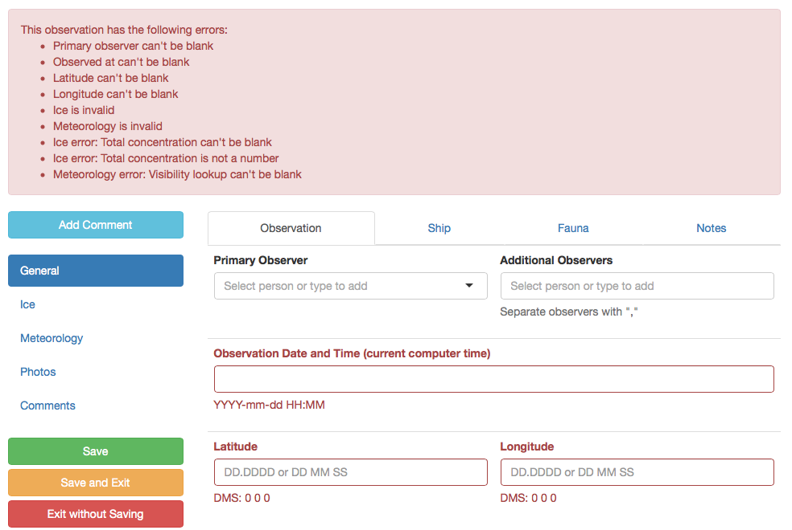

Screen Shot 1: General information that ASSIST requests.

In the following sections we describe the data entry in each tab of ASSIST. Please refer to the screen shots to identify the exact location for data entry.

***2.2.1 General***

Compulsory fields to enter data are the Primary Observer, Observation Data and Time, Latitude and Longitude.

Below the data entered in each of the tabs Observation, Ship, Fauna and Notes are described.

*2.2.1.1 General: Observation*

The first observation you make, enter your name in the Primary or Additional ***Observer*** box and click ‘Add your name’. This will populate the observer menu with your name so you can choose it for future observations.

***Date*** and ***time*** is automatically populated from the computer time. You will want to make sure the computer time is set to an appropriate time zone. Conversion to UTC is performed automatically, but to avoid any confusion it is recommended you set the computer time to UTC.

The ***latitude*** and ***longitude*** entry is picky on the format of the data entered. Pay special attention that these fields are saved correctly.

Positions can either be entered in decimal degrees, or as degrees and decimal minutes, or as degrees minutes and seconds. ***Make sure that you only include one space between degrees and minutes, and minutes and seconds. Otherwise the conversion to decimal degrees does not happen and only degrees are saved.***

*2.2.1.2 General: Ship*

Ship information is valuable for verifying the ice observation is consistent with the effort of the ship to maneuver in the ice or if the observation is biased by ship activity. ***Ship heading*** should be entered in degrees, ***ship speed*** in knots. ***Ship power*** is related to how many engines are running and in what capacity. Ship power is recorded in fourths of full power, which is all engines running at full capacity. If you have access to the bridge and it is allowable for you to talk to the Mates, they should be able to direct you towards where to obtain this information from the ships controls.

It is recommended you note the ***ship activity***. This is presented as a drop down menu to record whether the ship is traveling in leads or breaking ice, and if the ship is backing and ramming when breaking ice or on station. These last two options are useful in identifying repeat observations of the same ice.

*2.2.1.3 General: Fauna*

There is an option to enter Fauna observed in between and during observational periods. You can enter any number of species, with a quantity of each species observed. Note, the CSV output format for fauna (FN) is text separated by ‘//’ for each fauna type. Fauna count is integers separated by // for each fauna type recorded.

*2.2.1.4 General: Notes*

The Notes are three free format fields that can be used to include additional data entries of the observer’s choice.

ASSISTv4 does not provide the same fidelity as APSeCtv3 for brown ice (ice algae) observations. If you wish to record ASPeCt style brown ice observations it is recommended you use Note0 for this.

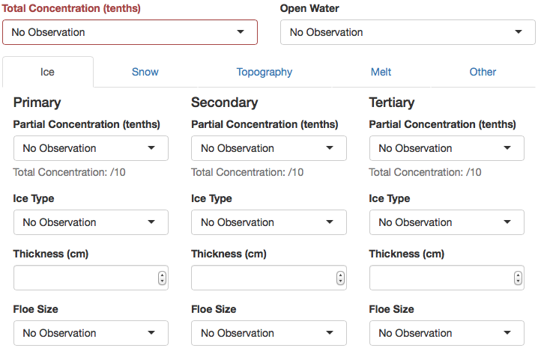

Screen Shot 2: ASSIST page for entering ice information.

***2.2.2 Ice***

To conduct the ice observation find a place to stand, or path to walk that gives you a 360o view of the region around the ship. First of all, take a long look at the ice around the ship.

The compulsory data that must be entered to make an ice observation is the ***total ice concentration***. Ice concentration is always recorded in tenths. The information in chart 2 will help you train your eye to gauge ice concentration.

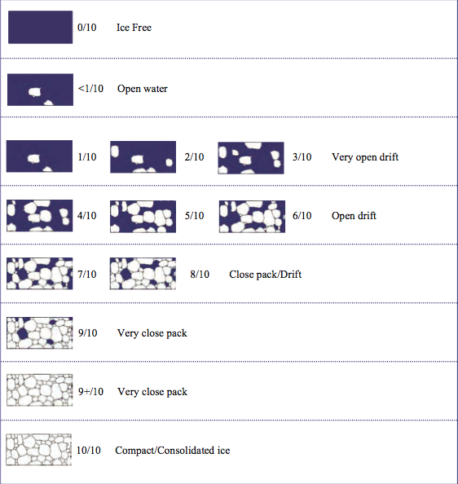

Figure 2: Examples of ice cover for various ice fractions. Reproduced from MANICE (Canadian Ice Service, 2005). This is from an aerial prospective, it would be nice to find a similar figure with a bridge perspective. If anyone in the ASSIST community would like to create one, please contact us.

In regions of very high ice concentration (95-99%) there can be small cracks present. This is recorded as 10/10 ice cover. Note that this should be consistent with an open water observation of small cracks. 100% ice cover does not contain cracks, which is identified by the open water classification.

There is much additional information to add from here on.

Table 1: Open water character.

|  |  |
| --- | --- |
| **OPEN WATER (OW)** |  |
| 0 :: No openings |  |
| 1 :: Small cracks |  |
| 2 :: Very narrow breaks, <50m |  |
| 3 :: Narrow breaks, 50-200m |  |
| 4 :: Wide breaks, 200-500m |  |
| 5 :: Very wide breaks >500m |  |
| 6 :: Leads |  |
| 7 :: Polynya |  |
| 8 :: Water broken only by scattered floes |  |
| 9 :: Open sea |  |
| 10 :: Strips and patches |  |

Together with concentration, describe the form of any ***open water*** in the observation area. Open water is classified as table 1. The open water description refers to water openings within the ice pack, not a fraction of water.

Note, open sea describes no sea ice present at all. It is a navigational definition of open sea.

Examples of open water types are shown photographically in figure 3, and advice on identifying open water provide in the box “How to identify open water type”.

Identify the ***ice types*** in the observation area. You will classify the three ice types that together cover the most area. Of these the thickest is the Primary ice type, and the thinnest the Tertiary ice type. Identify the area covered by each type. The area of primary, secondary and tertiary ice should sum to the total ice concentration.

***How to identify open water type***

Cracks and leads are long quasi-linear openings in the ice pack. Cracks are less than 5m wide and leads can be meters to many miles wide.

In loose pack you will encounter breaks in the ice pack that are much like lakes of water in shape. As the ship travels through these you can estimate their dimensions by comparing to the number of ship lengths it takes to travel through the break. Make sure you know the length of the vessel in meters. RADAR is also helpful in estimating sizes of open water areas.

Strips and Patches are encountered in low ice concentration and especially near the ice edge. These will be apparent on RADAR as long linear strips of RADAR targets. The width and distance between strips can vary, but they are pretty obvious as you go from very low ice concentration to high concentration and back to low concentration over a short time interval, over less than an hour.



Figure 3: Examples of open water.

***How to identify ice type***

Ice types can be identified from consideration of the thickness of the ice and whether the ice morphology indicates aging. These descriptions follow WMO (2014). Photographs of ice types are in figure 4.

***Frazil*** Ice that is forming as crystals in the water. It will appear as needles or plates suspended in the water.

***Grease*** A thin skin of frazil crystals congelated at the surface. This layer looks dark and greasy

***Shuga*** An accumulation of spongy white ice lumps, a few centimeters across; they are formed from grease ice or slush and sometimes from anchor ice rising to the surface.

***Slush*** Snow that is a viscous floating mass in water after a heavy snowfall.

***Pancakes*** Predominantly circular pieces of ice from 30 cm - 3 m in diameter, and up to about 10 cm in thickness, with raised rims due to the pieces striking against one another

***Nilas: light and dark*** A thin elastic crust of ice, easily bending on waves and swell and under pressure. Nilas has a matt surface, when less than 5cm is very dark in color. Nilas between 5 and 10cm is less dark.

***Grey-Ice*** *(Young Grey)*10-15 cm thick. Less elastic than nilas, it breaks under swell.

***Grey-White Ice*** (Young Grey) 15-30cm thick. When under pressure this ice is more likely to ridge that raft compared to grey-ice and nilas.

***First Year Ice*** Ice with of not more than one winters growth, thickness 30cm-2m.

This ice type is further classified by thickness in ASPeCt/ASSIST.

***Second Year Ice***  Ice that has survived one summer. Observers are referred to the manual described in Johnson & Timco (2008) for details on how to observe this ice type. A copy can be requested from the authors. If not familiar with this, type ice as first year or multiyear and skip use of the second year classification.

***Multiyear Ice*** Ice that has survived at least one summer’s melt. Most topographic features (ridges) are smoother than first year ice, as they become rounded in melt. Old ice appears whiter than first year ice.

***Brash*** is common between colliding floes or in regions where pressure ridges have collapsed. It is blocks of ice less than 2m is dimension.

***Landfast ice*** is held in situ by bathymetry, coastline, islands or grounded icebergs. In some parts of the Southern Ocean you may encounter landfast ice that has been released into the drifting pack. It is distinguished by it’s thickness in the Antarctic where landfast ice can grow to many meters in thickness over years to decades. In the Arctic it has similar thickness to first year or multiyear ice.



Figure 4: Photographs documenting examples of ice types.

The foundation of sea ice characterization is the Egg Code (Canadian Ice Service, 2005), where ice within a region is classified in three categories based on the ice type. These are referred to, in order of decreasing thickness, as the Primary, Secondary and Tertiary ice types. There are two additional catagories you can use for ice that has smaller area than the primary, secondary or tertiary types: A thick ice category (the thickest ice that has less than 10% cover) and one other thin ice type. These two additional fields can be found in the tab ice:other (section 2.2.2.5).

Within the observation region you may encounter only one or two ice types, and you may observe thick or other ice types with less than 10% cover. Record what you see, and leave black fields that do not correspond to any ice present.

In the Ice, Snow, Topography, Melt and Other tabs information is entered for each ice type that makes up more than 1/10 of the pack. The ice types are Primary (P), Secondary (S) and Tertiary (T). CSV data headers for the P,S and T fields are prefixed by P, S or T respectively. The letter codes following this prefix are given in the tables below with a * prefix.

*2.2.2.1 Ice: Ice*

***Partial Ice Concentration*** (*C) is entered in tenths. The ***ice*** ***type*** is noted, following the options in ‘How to identify ice type’. See figure 4 for photographic examples of ice type.

For each of the Primary, Secondary and Tertiary ice types you will record the characteristics of this ice separately. Note that Primary, Secondary and Tertiary in the ASSIST page refer to the ice type that remains constant across the tabs. Data is entered into the Ice, Snow. Topography, Melt and Other tabs for each ice type.

Enter ***ice thickness*** in centimeters, observed as described “How to estimate ice thickness”

***How to estimate ice thickness***

Ice breakers break ice by riding up onto it and using their weight to crack the ice. The result of this action is blocks of ice overturn on the flanks of the ship at some distance behind the bow. Typically you will be able to observe this looking through one of the stern facing windows of the bridge. You can train your eye to estimate the thickness of blocks that are fully overturned. By observing a series of overturning blocks during an observation period, you can estimate the thickness of level ice for each ice type the ship breaks. The precision of this estimate is 20cm for an experienced observer. Specific ships have different bounds on the thickness of ice that can be fully exposed in over turning. Thin ice does not over turn, and thick ice such as ridges may only partially overturn. Only estimate the thickness of the level ice. Thin ice thickness can be estimated from its color (see “How to identify ice type”). Once your eye is trained, you may be able to use freeboard to estimate thickness of level ice.

***Your thickness estimate should be the most common thickness of level ice observed for each ice type, over the 10 minute observation period.***

It is helpful to have an object near the water line of known dimension that you can train your eye to for estimating ice freeboard, thickness and snow thickness. This could be as simple as tying a fishing buoy of known diameter on a line over the side of the ship. Another aid can be to place a pole with 10cm painted blocks on it to a lower railing on the ship in a position visible from the bridge where ice tends to be overturned by the ship.

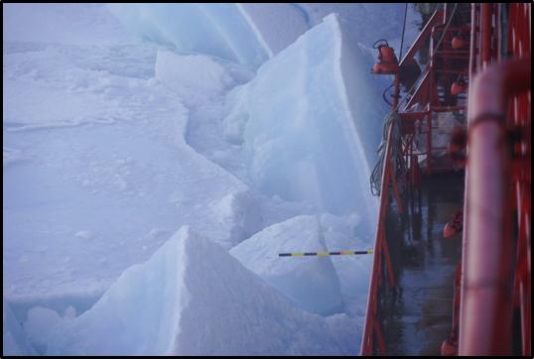

Figure 5: Painted pole used to aid eye in estimating ice thickness. Thanks Lauren Farmer and Alex Cowen.

The ***floe size*** is represented in standard language, following WMO (2014) convention (table 2). The floe size menu guides your choice. Note that certain floe sizes are only recorded for specific ice types. Pancakes form through a different process to sheet ice, and can grow to be meters in width and tens of centimeters in thickness. New sheet ice is used for newly forming nilas or grey ice on leads and polynyas. Thicker floes are classified by their largest dimensions. Brash is broken ice that is typically tens of centimeters to a meter in width. Finally, bergy floes are the ridge remnants found in a heavily melted pack.

Table 2: Floe size

|  |  |
| --- | --- |
| **FLOE SIZE (*F)** |  |
| 100 :: Pancakes |  |
| 200 :: New sheet ice |  |
| 300 :: Brash/Broken ice |  |
| 400 :: Cake ice, < 20m |  |
| 500 :: Small floes, 20-100m |  |
| 600 :: Medium floes, 100-500m |  |
| 700 :: Large floes, 500-2000m |  |
| 800 :: Vast floes, >2000m |  |
| 900 :: Bergy floes |  |

See “How to estimate floe size” for pointers on training your eye to gauge horizontal dimensions. The same concepts can be used to estimate the dimensions of open water breaks within the ice pack.



Figure 6: Photographs of ice of various floe sizes.

***How to estimate floe size***

The length of the ship can be used to gauge floe size. Make sure you know this length. You may also be able to identify large floes on the ships radar, and obtain dimensions from that. For floes or ice sheets consisting of cemented smaller floes, record the larger floe size. You can comment that cemented smaller floes, with a dimension, were observed. Floe edges are identified as cracks and leads, never ridges.

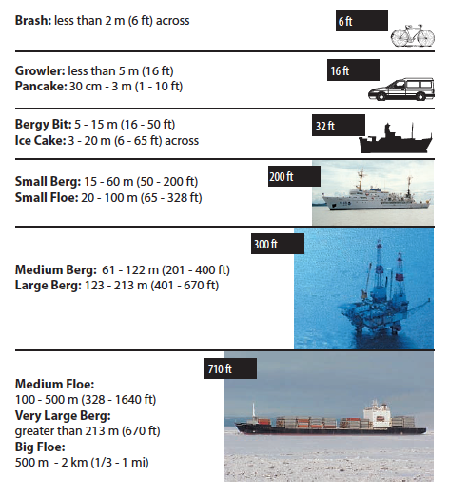

Figure 7: Objects useful for size reference in identifying floe size. Know the length of your ship. Reproduced from NOAA’s Observers Guide for Sea Ice (Smith).

*2.2.2.2 Ice: Snow*

The ***snow type*** on the ice surface should be recorded (table 3) together with the ***snow depth*** in centimeters. Snow depth is observed in the same way as ice thickness, though the mean depth is estimated. We aware, in summer after snow as melted, it is possible to mistake a granular melting layer of ice as snow. This will have a uniform thickness, unlike snow that blows into dunes.

Table 3: Snow type

|  |  |
| --- | --- |
| **SNOW TYPE (*SY)** |  |
| 00 :: No snow observation |  |
| 01 :: No snow, ice or brash |  |
| 02 :: Cold new snow, <1 day old |  |
| 03 :: Cold old snow |  |
| 04 :: Cold wind-packed snow |  |
| 05 :: New melting snow(wet new) |  |
| 06 :: Old melting snow |  |
| 07 :: Glaze |  |
| 08 :: Melt slush |  |
| 09 :: Melt puddles |  |
| 10 :: Saturated snow |  |
| 11 :: Sastrugi |  |

Record the state of the surface of the snow. If melt is observed at the surface this determines the snow type. Glaze is melted snow or rain that is refrozen. Sastrugi are characteristic mounds or dunes of snow that are wind blown, they tend to align to the wind direction.

*2.2.2.3 Ice: Topography*

Identify if the ice is level, if there are finger rafts in new ice or ridges present. Consider each ice type separately when recording the topography of the ice. You first record the topography type (level ice, rafted pancakes, cemented pancakes, rafting or ridges). If there are ridges present, you will estimate the height of the ridges and the area of ice they cover.

The area they cover is the fractional coverage of the ice type they are on. This is given in tenths, of the fractional ice area of the specific type, not the total area. For example, if there is 20% multi-year ice present, and this multi-year ice is only 20% level ice, the topography area is 80%. Pay attention to perspective effects when estimating ridge cover. Do not look too far from the ship as at a distance the area between ridges appears reduced and ridge peaks more dominant in the field of view, and you can easily bias your ridge area estimate high.



Figure 8: Topography types, and ridge classifications. Photographs from the ASPeCt observation guide.

Ridge height is estimated to the half meter. This should be the mean ridge sail height. It is tricky to estimate ridge height from a ship, as perspective from the bridge leads to an underestimate in the height. It is particularly important to compare ridge height observations between different observers for the same scene, to standardize observations. Also, taking a perspective from a low deck on the ship, venturing onto the ice or airborne measurements can help provide a bench mark to correct the perspective bias.

Finally, there are three logical checks to make to identify the age and form of the ridges. Are the ridges snow covered? Are ridges consolidated? Un-consolidated ridges will fall apart into blocks when the ship rides over them. Are the ridges old? Old ridges are ridges that have weathered a melt season or more. They are smoother in shape compared to blocky first year ridges.

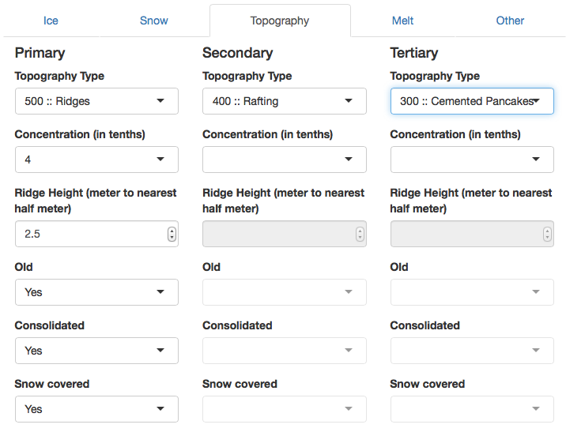

Screen Shot 3: Topography data entry in ASSIST.

The way ice surface topography is recorded in ASSIST is different to ASPeCt as the user is guided through recording the observation with menu options. The resulting data is fully compatible with the ASPeCt coding system (see Appendix C). Make sure to fill out all requested information if you want to use the ASPeCt style topography data in your analysis.

*2.2.2.4 Ice: Melt*

Surface melt is not recorded in ASPeCt observations. It was incorporated into ASSIST in order to characterize stage of melt and melt pond cover. See appendix C for how to characterize stage of melt with the data.

If there are melt ponds (puddles) present, estimate the fractional area of ice, separately for each type, covered by melt ponds. This is recorded in tenths.

Next you may record some information about the melt ponds. Are the ponds linked or discrete (figure 9). Typically melt ponds forming in depressions on multi-year ice will be discrete, due to the hummocked topography of the ice.

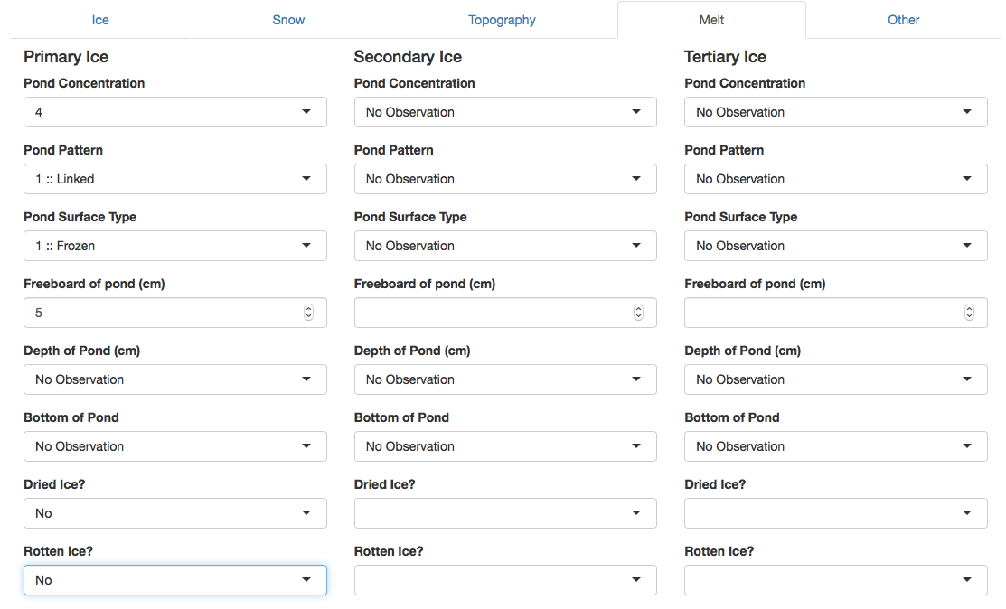

Screen Shot 4: Stage of melt data entry in ASSIST.

Record if melt ponds surfaces are frozen or open (not frozen). The “Bottom Up” surface type is for melt ponds with detached bottoms floating in their centers. These detached bottoms tend to look rotten, being grey and porous.

The bottom type of the melt pond is important for stage of melt characterization. Record if there are thaw holes in the pond floor. The classification is no melt ponds have thaw holes (solid), some have thaw holes or all have thaw holes.

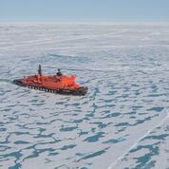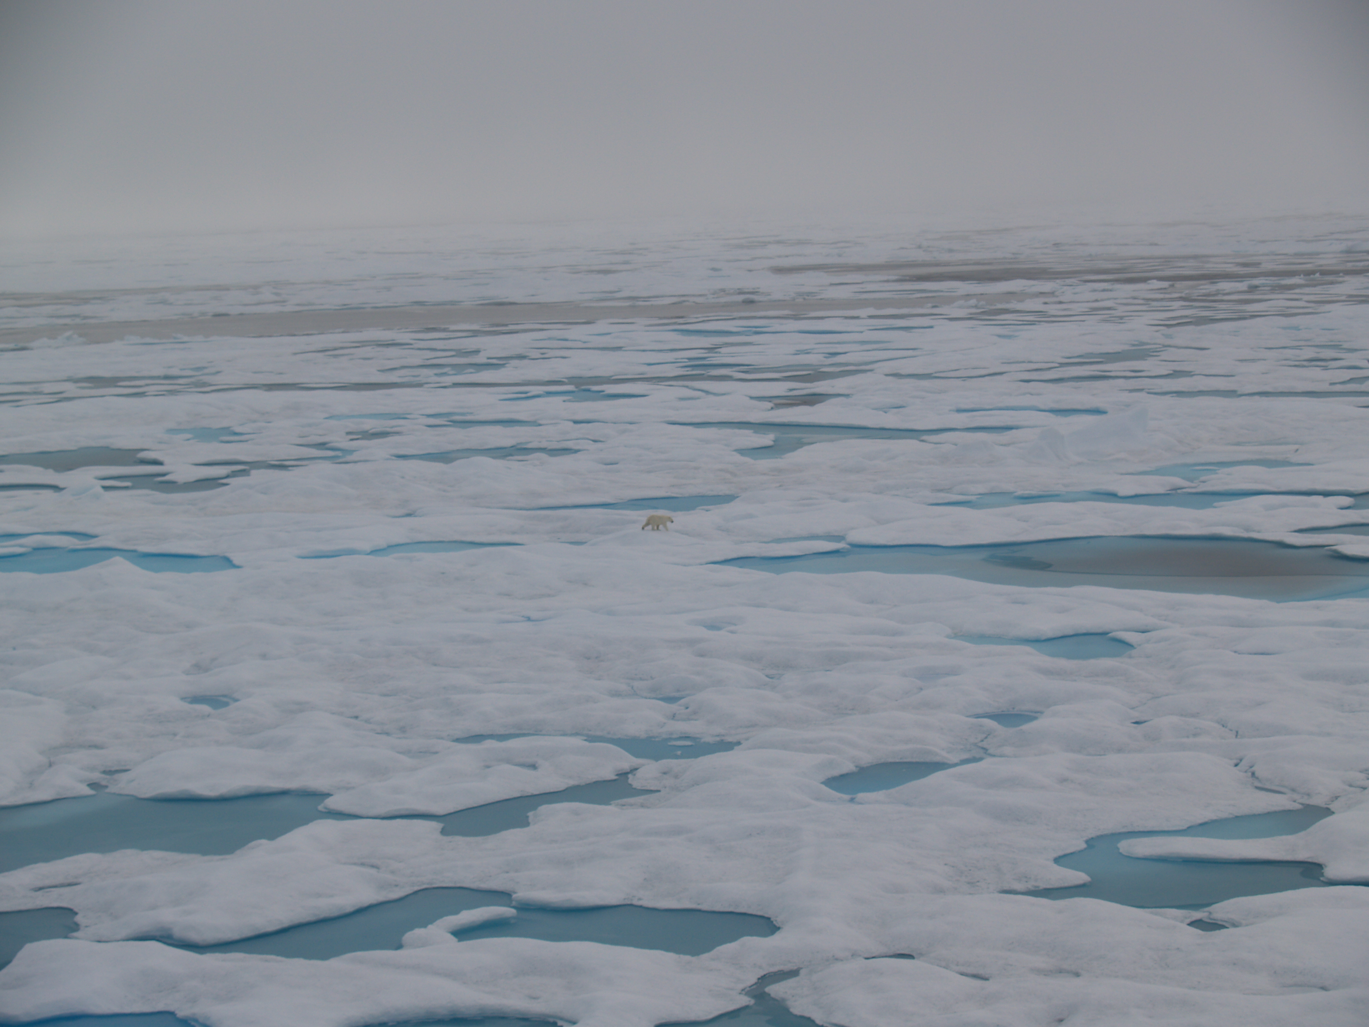

Figure 9: Photographs of linked melt ponds typical on level first year ice (left) and discrete melt ponds on older ice (right).

Experienced observers can estimate the melt pond freeboard, which is the height of the ice freeboard above the melt pond surface in centimeters. The melt pond depth is also recorded in centimeters. Typically you will need to have performed melt pond measurements in-situ to train your eye to estimate depth.

The last two melt characteristics are related to the ice itself and not melt ponds. At later stages of summer melt the ice can dry out, and will appear bright white. This is a sign the ice is warm, brine channels larger and all brine drained from the ice. The final state of melt is rotten ice. This ice is grey and waterlogged in appearance, often with large pits and holes through it. Dried ice and rotten ice are two logical variables chosen by menu in ASSIST.

*2.2.2.5 Ice: Other*

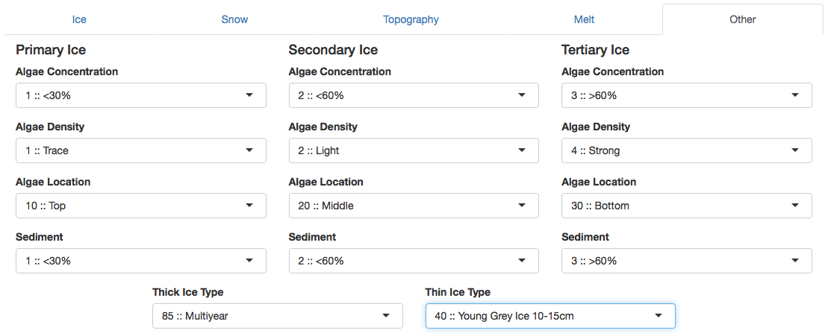

Screen shot 5: Where brown ice (ice algae) data, sediment presence in ice and the thick ice and other ice types are recorded.

Ice that is affected by algae growth is colored and sometimes referred to as ***Brown ice.*** The color can be matched to a density of algae in the ice. Use the color swatches in figure 11 to identify the ***algae density***. The algae concentration is the fractional coverage of algae on ice of that type. The algae can be located at the top, middle or bottom of the ice (see photos in figure 10). In the Arctic it is commonly found on the bottom of the ice, and will only be observed sporadically when ice is over turned. Estimate the fraction of over turned ice of each type with bottom/middle algae colonies.

***Sediment laden ice*** has typically originated on shelf seas where turbulence while the ice is forming entrains sediment from the sea floor into the ice. This typically appears dark brown or black and is sometimes pocketed in the ice. In summer sediment can lead to a pock-marked ice surface as the higher albedo of the sediment leads to preferential melting. Record the percentage fraction of the ice type covered in sediment.



Figure 10: Ice algae communities observed in overturned ice. The bottom communities are shown on blocks that are completely overturned, the top and interior communities in blocks that are in the process of overturning.

**How to identify ice algae**

When ice is overturned by the ship look for yellow or brown coloration in the ice. Note the location, and color against the color chart in figure 11.

Sediment is typically darker in color and not uniformly distributed through the ice, but rather in pockets.



Figure 11: Ice algae density color chart

There are two additional fields in the other tab that are not associated with primary, secondary or tertiary ice types. These are the thick ice type or the other (thin) ice type. These are only recorded for ice covering less than 10% of the full observational scene. The ice types are explained in the box “How to identify ice type” in section 2.2.2.1.

***2.2.3 Meteorology***

***Visibility*** is a required observation. Without visibility, it can not be judged what area of ice the observations is representative off. Record visibility following the code provided in table 4. Fog is common in summer.

Table 4: Visibility

|  |  |
| --- | --- |
| **VISIBILITY (V)** | m-km |
| 90 :: <50m |  |
| 91 :: 50-200m |  |
| 92 :: 200-500m |  |
| 93 :: 500-1000m |  |
| 94 :: 1-2km |  |
| 95 :: 2-4km |  |
| 96 :: 4-10km |  |
| 97 :: >10km |  |

A variety of meteorological observations can be recorded. ***Total cloud cover*** is estimated in oktas. The clouds are identified, the cloud type determines whether the cloud is high, medium or low height in the atmosphere. For each dominant cloud type at each level record that type (as in table 5). Estimate the cover of cloud at each height, in oktas. The total should equal the total cloud cover. Cloud type, cloud height and partial cloud covers are entered in the tab titled “Cloud”.

Table 5: Cloud Types available in ASSIST

|  |  |
| --- | --- |
| **HIGH CLOUD TYPE (HY)** |  |
| Ci :: Cirrus |  |
| Cs :: Cirrostratus |  |
| Cc :: Cirrocumulus |  |
|  |  |
| **MED. CLOUD TYPE (MY)** |  |
| As :: Altostratus |  |
| Ac :: AltoCumulus |  |
|  |  |
| **LOW CLOUD TYPE (LY)** |  |
| St :: Stratus |  |
| Sc :: Stratocumulus |  |
| Ns :: Nimbostratus |  |
| Cu :: Cumulus |  |
| Cn :: Cumulonimbus |  |

A good guide to cloud observing, with images, is “Cloud types for observers” published by the United Kingdom Met Office (Met Office 2006).

Other measurements that can be recorded if they are available are wind speed (in knots), wind direction (degrees), air temperature (Celsius), water temperature (Celsius), relative humidity (%) and air pressure (millibars). Wind speed must be recorded as the true wind speed, which is observed wind speed on the ship minus the ship speed.

It important you check the meteorological instruments recording this data. Thermometers must be shaded and not upwind of air vents from the ship. Check that anemometers and hydrometers are not iced. Water temperature can be measured from a hull-mounted probe, or by bucket sample. Only record data if you can assure it’s quality.

Finally the present ***weather*** is recorded according the table given in appendix A. This table is a list of standard WMO codes for visual observations of current weather (WMO 2011), reduced to only include the weather that occurs in the polar regions.

The ***ASSIST WX table is keyword and number searchable*** from the Weather data entry box. Type a keyword in the field to search for that element in the list. For example, "snow" will return a list of all codes/descriptions with "snow" in the text.

***Photos***

Any number of photos can be attached to an observation, and it can be specified if the photo is taken facing the ship’s bow, port or starboard. The CSV output (Photo) only provides the number of photos uploaded with each observation.

***It is highly recommended that you give the photographs a filename that identifies the observation they are associated with***. ASSIST CSV output does not identify photo file names, and photos are linked to observations through the underlying SQL database ASSIST uses. If you zip the photos in the ASSIST archive, they are not saved with metadata about the observation they are attached to.

***Comments***

Comments can be attached in each tab with the ‘Add Comment’ button. Any number of comments can be entered. Comment strings are included in CSV output in the final column, Comments. The comment string is formatted as:

“\”Comment Text – Observer Name\””//”\”Second Comment Text – Observer Name\””

Clicking on the “Comments” button in the left menu in ASSIST will show you all the comments entered for that observation.

***2.3 Data Entry Direct from CSV (not highly recommended!)***

Experienced observers may prefer to enter codes directly into a spreadsheet, or use paper and pencil on the bridge and enter to a spreadsheet later. CSV data can be directly uploaded to the Ice Watch archive. However do note, this does remove the advantage ASSIST gives in quality controlling data while observing. If this method of data entry is used, extreme care must be paid to the format of the data entry. In particular:

1. Time must be entered as YYYY-MM-DD HH:MM:SS UTC. Note that you can use the ‘custom’ cell formatting (yyyy-m-d hh:mm:ss UTC) to set times to this format in excel.
2. Latitude and longitude must be in decimal degrees.
3. Ensure logical values are entered as TRUE or FALSE.
4. Leave entries blank where no observation was taken.

An excel file with data headers is provided with the ASSIST distribution. Please manipulate this file to match your needs. We suggest you hide or delete the columns you do not need, change column widths to accept hand writing if you are working with printed sheets, and add lines to the file to lead your eye to the columns you will fill. Maintain the column headers exactly as provided, as ASSIST uses these headers in the first line of the csv file to identify the data fields. Note that ASSIST does not care about the order of columns, however you will need to be vigilant in checking the data is correctly uploaded. Export your data as csv. You can upload this csv file directly into ASSIST to use the ASSIST quality control functions. We recommend you do this quality control while on the ship.

***3. Archiving Ice Watch Data***

Data is archived through a website hosted by the Norwegian Meteorological Institute ([https://icewatch.met.no](https://icewatch.met.no/)). The online data entry uses the same web interface as ASSIST for error correction and checking. You will need to create an account on the Ice Watch website to get access to the data management functions and upload data.

Both ASSIST and the Ice Watch archive allow upload of CSV data files, such that experienced observers do not need to use the web interface, and quality control can be conducted offline.

Please use ASSIST to quality control data prior to upload at the Ice Watch website: icewatch.met.no. Once you are logged into the website you will see a button to ‘create cruise’. Click this and enter cruise meta data. This will create the cruise in the data menu on the left hand side. Click on your cruise, which will lead you to a new page where you will find an option to upload data from CSV. Do so, and check that the data is error free. Just as in ASSIST, and using the same quality control as ASSIST, the Ice Watch site highlights erroneous data in pink. You can either edit the data through the Ice Watch interface (just as you do in ASSIST), or edit off-line in the CSV files. If you choose to edit offline, note there is an option to delete all data so you can upload a clean data set from a CSV file.

Photos should be zipped into a single file, retaining their filenames, for upload to the Ice Watch database.

Refer to the data upload guide in Appendix D for instructions on how to save and archive your data.

Data here will be managed by the Ice Watch team and archived in the Alfred Wegner Institute Pangea data archive. It is freely available for download without registration with Ice Watch.

***Acknowledgements***

IceWatch has been supported by the National Science Foundation (NSF PLR-1304315), through the Sea Ice Prediction Network and by the Japan Aerospace Exploration Agency (JAXA) under the “Arctic Research Plan Utilizing the IARC-JAXA Informatin System (IJIS) and Satellite Imagery”. The Climate of the Cryosphere (CliC) has provided logistical support in developing the Ice Watch collaboration and hosts a technical working group facilitating conversations and integration with the SCAR/ASPeCt team.

The design of the Ice Watch standardized observing method and ASSIST software has been developed from numerous conversations with many Arctic field researchers both informally and during CliC Sea Ice Working Group meetings and other ad-hoc meetings during international conferences. These conversations were led by Alice Orlich. There are too many contributors to be listed by name here. John Falkingham is thanked for discussions invaluable in developing the SIGRID-3 conversion of Ice Watch data.

Scott MacFarlane, Geographical Information Network of Alaska, designed the Ice Watch database and ASSIST software. Will Fisher, Ross Spicer and Jason Grimes all contributed to the software.

**Appendix A: ASSIST Observation Code Digest**

Ice Watch observations are organized in the ASSIST data input interface into a series of tabs: General, Ice, Meteorology, Photos and Comments. In the description of the observation codes below we present the data in tables associated with each tab. ASSIST data can be output in comma separated value, CSV, format. The header for each data column is given in brackets next to the observable name in the following tables.

***General: Observation***

|  |
| --- |
| **PRIMARY OBSERVER (PO)** |
| **ADDITIONAL OBSERVER/S (AO)** |
| Full name |
| *Add your name to the menu on first observation.* |
| **OBSERVATION DATE/TIME (Date)** |
| YYYY-MM-DD HH:MM:SS UTC |
| *Converts computer time to UTC automatically.* |
| **LATITUDE (LAT)** |
| **LONGITUDE (LON)** |
| DDD.DDD or DDD MM SS or DD MM.MMM |
| *Converts to decimal degrees automatically.* |

***General: Ship***

|  |  |  |  |  |
| --- | --- | --- | --- | --- |
| **SHIP HEADING (ShH)** | degrees |  | **SHIP SPEED (ShS)** | knots |
| Nearest degree |  |  | Nearest knot |  |
|  |  |  |  |  |
| **SHIP POWER (ShP)** |  |  | **SHIP ACTIVITY (ShA)** |  |
| Not Specified |  |  | Not Specified |  |
| 0 |  |  | 10 :: Traveling in leads |  |
| 1/4 |  |  | 20 :: Traveling in ice |  |
| 1/2 |  |  | 30 :: Back and ramming |  |
| 3/4 |  |  | 40 :: On station |  |
| Full |  |  |  |  |

***General: Fauna***

|  |  |
| --- | --- |
| **FAUNA NAME (FN)** | |
| Common or scientific name | |
| *Any number of fauna types can be added* | |
| **FAUNA COUNT (FC)** | |
| Number of reported species | |
|  |  |

***General: Notes***

|  |
| --- |
| **NOTES (note0, note1, & note2 )** |
| Observer's notes, free format |

Three free format fields that can be used to include additional data entries of the observers choice.

***Ice***

|  |  |
| --- | --- |
| **TOTAL ICE CONCENTRATION (TC)** | Tenths |
| **PARTIAL ICE CONCENTRATION (*C)** |  |
| 0 :: 1/10 |  |
| 1 :: 1/10 |  |
| 2 :: 2/10 |  |
| 3 :: 3/10 |  |
| 4 :: 4/10 |  |
| 5 :: 5/10 |  |
| 6 :: 6/10 |  |
| 7 :: 7/10 |  |
| 8 :: 8/10 |  |
| 9 :: 9/10 |  |
| 10 :: 10/10 |  |

|  |  |
| --- | --- |
| **OPEN WATER (OW)** |  |
| 0 :: No openings |  |
| 1 :: Small cracks |  |
| 2 :: Very narrow breaks, <50m |  |
| 3 :: Narrow breaks, 50-200m |  |
| 4 :: Wide breaks, 200-500m |  |
| 5 :: Very wide breaks >500m |  |
| 6 :: Leads |  |
| 7 :: Polynya |  |
| 8 :: Water broken only by scattered floes |  |
| 9 :: Open sea |  |
| 10 :: Strips and patches |  |

In the Ice, Snow, Topography, Melt and Other tabs information is entered for each ice type. The ice types are Primary (P), Secondary (S) and Tertiary (T). CSV data headers for the P,S and T fields are prefixed by P, S or T respectively. The letter codes following this prefix are given in the tables below with a * prefix.

***Ice: Ice***

Partial Ice Concentration (*C) is entered following the table for TC.

|  |  |
| --- | --- |
| **ICE TYPE (*T)** |  |
| **OTHER ICE TYPE THIN (OT)** |  |
| **OTHER ICE TYPE THICK (TH)** |  |
| 10 :: Frazil |  |
| 11 :: Shuga |  |
| 12 :: Grease |  |
| 13 :: Slush |  |
| 20 :: Nilas |  |
| 30 :: Pancakes |  |
| 40 :: Young Grey Ice, 10-15cm |  |
| 50 :: Young Grey Ice, 15-30cm |  |
| 60 :: First Year, < 70cm |  |
| 70 :: First Year, 70-120cm |  |
| 80 :: First Year, > 120cm |  |
| 75 :: Second Year |  |
| 85 :: Multiyear |  |
| 90 :: Brash |  |
| 95 :: Fast Ice |  |

|  |  |
| --- | --- |
| **ICE THICKNESS (*Z)** | cm |
| Total ice thickness in cm |  |

|  |  |
| --- | --- |
| **FLOE SIZE (*F)** |  |
| 100 :: Pancakes |  |
| 200 :: New sheet ice |  |
| 300 :: Brash/Broken ice |  |
| 400 :: Cake ice, < 20m |  |
| 500 :: Small floes, 20-100m |  |
| 600 :: Medium floes, 100-500m |  |
| 700 :: Large floes, 500-2000m |  |
| 800 :: Vast floes, >2000m |  |
| 900 :: Bergy floes |  |

***Ice: Snow***

|  |  |
| --- | --- |
| **SNOW TYPE (*SY)** |  |
| 00 :: No snow observation |  |
| 01 :: No snow, ice or brash |  |
| 02 :: Cold new snow, <1 day old |  |
| 03 :: Cold old snow |  |
| 04 :: Cold wind-packed snow |  |
| 05 :: New melting snow(wet new) |  |
| 06 :: Old melting snow |  |
| 07 :: Glaze |  |
| 08 :: Melt slush |  |
| 09 :: Melt puddles |  |
| 10 :: Saturated snow |  |
| 11 :: Sastrugi |  |

|  |  |
| --- | --- |
| **SNOW DEPTH (*SN)** | cm |
| Depth of surface snow |  |

***Ice: Topography***

|  |  |
| --- | --- |
| **TOPOGRAPHY TYPE (*Top)** |  |
| 100 :: Level ice |  |
| 200 :: Rafted Pancakes |  |
| 300 :: Cemented Pancakes |  |
| 400 :: Rafting |  |
| 500 :: Ridges |  |

|  |  |
| --- | --- |
| **TOPOGRAPHY CONC (*TopC)** | Tenths |
| 0 :: 0/10 |  |
| 1 :: 1/10 |  |
| 2 :: 2/10 |  |
| 3 :: 3/10 |  |
| 4 :: 4/10 |  |
| 5 :: 5/10 |  |
| 6 :: 6/10 |  |
| 7 :: 7/10 |  |
| 8 :: 8/10 |  |
| 9 :: 9/10 |  |
| 10 :: 10/10 |  |

*TopC is the fractional area of ice, separately for each type, covered by ridges or rafts

|  |  |
| --- | --- |
| **RIDGE HEIGHT (*RH)** | m |
| To nearest half meter |  |

|  |  |
| --- | --- |
| **TOPO FEATURE OLD? (*Old)** | |
| **TOPO FEATURE CONSOLIDATED? (*Cs)** |  |
| **TOPO FEATURE SNOW-COVERED? (*SC)** |  |
| Yes :: True |  |
| No :: False |  |

***Ice: Melt***

|  |  |
| --- | --- |
| **MELT POND CONC (*MPC)** | Tenths |
| 0 :: 0/10 |  |
| 1 :: 1/10 |  |
| 2 :: 2/10 |  |
| 3 :: 3/10 |  |
| 4 :: 4/10 |  |
| 5 :: 5/10 |  |
| 6 :: 6/10 |  |
| 7 :: 7/10 |  |
| 8 :: 8/10 |  |
| 9 :: 9/10 |  |
| 10 :: 10/10 |  |

*MPC is the fractional area of ice, separately for each type, covered by meltponds

|  |  |
| --- | --- |
| **MELT POND PATTERN (*MPP)** |  |
| 1 :: Linked |  |
| 2 :: Discrete |  |

|  |  |
| --- | --- |
| **MELT POND SURFACE TYPE (*MPT)** |  |
| 1 :: Frozen |  |
| 2 :: Open |  |
| 3 :: Bottom up |  |

|  |  |
| --- | --- |
| **MELT POND FREEBOARD (*MPF)** | cm |
| Height of MP freeboard above MP surface | |

|  |  |
| --- | --- |
| **MELT POND DEPTH (*MPD)** | cm |
| 1 :: 0-10cm |  |
| 2 :: 10-30cm |  |
| 3 :: 30-50cm |  |
| 4 :: >50cm |  |
| -9 :: Unknown |  |

|  |  |
| --- | --- |
| **MELT POND BOTTOM TYPE (*MBT)** |  |
| 1 :: Solid |  |
| 2 :: Some have thaw holes |  |
| 3 :: All have thaw holes |  |

|  |  |
| --- | --- |
| **DRIED ICE? (*MDI)** |  |
| **ROTTEN ICE? (*MRI)** |  |
| Yes :: True |  |
| No :: False |  |

***Ice: Other***

|  |  |
| --- | --- |
| **ALGAE CONC. (*A)** | % |
| **SEDIMENT CONC. (*SD)** |  |
| 0 :: 0% |  |
| 1 :: <30% |  |
| 2 :: <60% |  |
| 3 :: >60% |  |

*A and *SD is the percentage area of the ice, of any given type, with algae or sediment present.

|  |  |
| --- | --- |
| **ALGAE LOCATION (*AL)** |  |
| 1 :: Top |  |
| 2 :: Middle |  |
| 3 :: Bottom |  |

|  |  |
| --- | --- |
| **ALGAE DENSITY (*AD)** |  |
| 0 :: Not Visible |  |
| 1 :: Trace |  |
| 2 :: Light |  |
| 3 :: Medium |  |
| 4 :: Strong |  |
| *See Colour Chart* |  |

Two fields in Ice: Other not associated with P*, S* or T*.

Other Ice Type Thick (TH)

Other Ice Type Thin (OT)

The codes for these types are given in the ice type table.



***Meteorology***

|  |  |
| --- | --- |
| **VISIBILITY (V)** | m-km |
| 90 :: <50m |  |
| 91 :: 50-200m |  |
| 92 :: 200-500m |  |
| 93 :: 500-1000m |  |
| 94 :: 1-2km |  |
| 95 :: 2-4km |  |
| 96 :: 4-10km |  |
| 97 :: >10km |  |

|  |  |
| --- | --- |
| **TOTAL CLOUD COVER(TCC)** | Oktas |
| **HIGH CLOUD COVER (HV)** |  |
| **MEDIUM CLOUD COVER (MV)** |  |
| **LOW CLOUD COVER (LV)** |  |
| 0 :: 0 |  |
| 1 :: 1/8 or less, but not 0 |  |
| 2 :: 2/8 |  |
| 3 :: 3/8 |  |
| 4 :: 4/8 |  |
| 5 :: 5/8 |  |
| 6 :: 6/8 |  |
| 7 :: 7/8 or more, but not 8/8 |  |
| 8 :: 8/8 |  |

|  |  |
| --- | --- |
| **WIND SPEED (WS)** | Knot |
| Nearest knot |  |
|  |  |
| **WIND DIRECTION (WD)** | Degree |
| Nearest degree |  |
|  |  |
| **AIR TEMPERATURE (AT)** | °C |
| Nearest degree, C |  |
|  |  |
| **WATER TEMPERATURE (WT)** | °C |
| Nearest degree, C |  |
|  |  |
| **RELATIVE HUMIDITY (RelH)** |  |
| Nearest % |  |
|  |  |
| **AIR PRESSURE (AP)** | mBar |
| Nearest mBar |  |

***Weather (WX)***

Note, the ASSIST table is keyword and number searchable from the Weather data entry box.

|  |  |
| --- | --- |
| **00-03 Sky Change During Past Hour** |  |
| 000 :: Clouds not observable/observed |  |
| 001 :: Clouds dissolving/becoming less developed |  |
| 002 :: State of sky as a whole unchanged |  |
| 003 :: Clouds forming or developing |  |
| **10-13 Mist and Shallow Fog** |  |
| 010 :: Mist (Visibility 1/2 nm or more) |  |
| 011 :: Shallow fog in patches |  |
| 012 :: Shallow fog, more or less continuous |  |
| |  | | --- | | **40-49 Fog at the Time of Ob** | | 040:: Fog: distance, not at ship in past hour, Vis may be >1/2nm | | 041 :: Fog in patches | | 042 :: Fog thinning in last hour, sky discernable | | 043 :: Fog thinning in last hour, sky not discernable | | 044 :: Fog unchanged in last hour, sky discernable | | 045 :: Fog unchanged in last hour, sky not discernable | | 046 :: Fog beginning/thickening in last hour, sky discernable | | 047 :: Fog beginning/thickening in last hour, sky not discernable | | 048 :: Fog depositing rime, sky discernable | | 049 :: Fog depositing rime, sky not discernable | | **50-59 Drizzle** | | 050 :: Slight drizzle, intermittent | | 051 :: Slight drizzle, continuous | | 052 :: Moderate drizzle, intermittent | | 053 :: Moderate drizzle, continuous | | 054 :: Dense drizzle, intermittent | | 055 :: Dense drizzle, continuous | | 056 :: Freezing drizzle, slight | | 057 :: Freezing drizzle, moderate or dense | | 058 :: Drizzle and rain, slight | | 059 :: Drizzle and rain, moderate or dense | | **60-69 Rain NOT Falling as Showers** | | 060 :: Slight rain, intermittent | | 061 :: Slight rain, continuous | | 062 :: Moderate rain, intermittent | | 063 :: Moderate rain, continuous | | 064 :: Heavy rain, intermittent | | 065 :: Heavy rain, continuous | | 066 :: Freezing rain, slight | | 067 :: Freezing rain, moderate or heavy | | 068 :: Rain or drizzle and snow, slight | | 069 :: Rain or drizzle and snow, moderate/heavy | | |
| **14-16 Precipitation not at ship** |  |
| 014 :: Precipitation in sight, not reaching surface |  |
| 015 :: Precipitation beyond 3nm, reaching surface |  |
| 016 :: Precipitation within 3nm, reaching surface |  |
| **20-29 Past Hour but NOT at observation time** |  |
| 020 :: Drizzle not freezing or snow grains |  |
| 021 :: Rain not freezing or snow grains |  |
| 022 :: Snow not freezing or snow grains |  |
| 023 :: Rain and snow or ice pellets |  |
| 024 :: Drizzle or rain, freezing |  |
| 025 :: Showers of rain |  |
| 026 :: Showers of snow, or of rain and snow |  |
| 027 :: Showers of hail, or of rain and hail |  |
| 028 :: Fog in past hour, not at present |  |
| 029:: Thunderstorm, with or without precip |  |
| **36-39 Unique Snow Conditions** |  |
| 036 :: Drifting snow below eye level, slight/moderate |  |
| 037 :: Drifting snow below eye level, heavy |  |
| 038 :: Blowing snow, above eye level, slight/moderate |  |
| 039 :: Blowing snow, above eye level, heavy |  |
| |  | | --- | | **70-79 Solid Precip. Not as Showers** | | 070 :: Slight fall of snow flakes, intermittent | | 071 :: Slight fall of snow flakes, continuous | | 072 :: Moderate fall of snow flakes, intermittent | | 073 :: Moderate fall of snow flakes, continuous | | 074 :: Heavy fall of snow flakes, intermittent | | 075 :: Heavy fall of snow flakes, continuous | | 076 :: Ice prisms, with/without fog | | 077 :: Snow grains, with/without fog | | 078 :: Isolated star like crystals | | 079 :: Ice pellets | | **80-84 Rain Showers** | | 080 :: Slight rain showers | | 081 :: Moderate or heavy rain showers | | 082 :: Violent rain showers | | 083 :: Slight showers of rain and snow | | 084 :: Moderate/heavy showers of rain and snow | | **85-90 Solid Precipitation in Showers** | | 085 :: Slight snow showers | | 086 :: Moderate or heavy snow showers | | 087 :: Slight showers of soft or small hail | | 088 :: Moderate/heavy showers of soft/small hail | | 089 :: Slight showers of hail | | 090 :: Moderate or heavy showers of hail | |  |

***Meteorology: Cloud***

|  |  |
| --- | --- |
| **HIGH CLOUD TYPE (HY)** |  |
| Ci :: Cirrus |  |
| Cs :: Cirrostratus |  |
| Cc :: Cirrocumulus |  |
|  |  |
| **MED. CLOUD TYPE (MY)** |  |
| As :: Altostratus |  |
| Ac :: AltoCumulus |  |
|  |  |
| **LOW CLOUD TYPE (LY)** |  |
| St :: Stratus |  |
| Sc :: Stratocumulus |  |
| Ns :: Nimbostratus |  |
| Cu :: Cumulus |  |
| Cn :: Cumulonimbus |  |
|  |  |
| **HIGH CLOUD HEIGHT (HH)** | km |
| 3 - 8km |  |
|  |  |
| **MEDIUM CLOUD HEIGHT (MH)** | km |
| 2 - 4km |  |
|  |  |
| **LOW CLOUD HEIGHT (LH)** | km |
| Surface - 2km |  |

***Photos***

Any number of photos can be attached to an observation, and it can be specified if the photo is taken facing the ship’s bow, port or starboard. The CSV output (Photo) only provides the number of photos uploaded with each observation.

***Comments***

Comments can be attached in each tab with the ‘Add Comment’ button. Any number of comments can be entered. Comment strings are included in CSV output in the final column, Comments. The comment string is formatted as:

“\”Comment Text – Observer Name\””//”\”Second Comment Text – Observer Name\””

**Appendix B: Differences between ASPeCt and ASSIST**

ASSIST is fully backward compatible to ASPeCt, such that any ASSIST observation can be transformed into the ASPeCt format. Additional fields are included in ASSIST to characterize ice conditions more typically found in the Arctic than the Antarctic. Additional fields have been included in ASSIST that are of utility to both Arctic and Antarctic observers. These include fields describing the ice surface melt, sediment and algae in ice, fauna, additional ice types and meteorological fields, and information about ship travel.

ASSIST utilizes the same menus and has the same observables as ASPeCt except for the following exceptions and observations that are not routinely included in ASPeCt.

***Ship activity fields***

Unique to ASSIST

***Algae and sediment fields***

Unique to ASSIST, except for algae density and algae location. The density uses the same color swatches for identification in both ASSIST and ASPeCt. Subtract 1 from the ASSIST density to obtain the ASPeCt density.

Density and algae location are encoded in ASPeCt version 3 as a three digit number. The first digit is the algae density at the top of the ice, middle digit the density in the middle of the ice, and the third digit density at the base of the ice. The algae density is recorded between 0 (trace) and 3 (strong) in ASPeCt. ASSIST does not allow multiple locations to be input for each ice type. This may be fixed in future versions, if there is demand and funding.

***Fauna fields***

Unique to ASSIST

***Additional Notes***

Unique to ASSIST

***Ice Type***

Additional ice types in ASSIST are slush and second year ice.

***Floe size***

Additional floe sizes in ASSIST are vast floes that are greater than 2000m in dimension.

***Melt***

All fields are unique to ASSIST

ASPeCt version 3 includes melt pond fraction and and two melt pond diameters to be recorded. The ASSIST characterization of melt was designed to identify pertinent aspects of stage of melt for operational and research use.

Table C1: Stage of Melt Classification for different ice types. Following Russian ice observer convention (pers. comm. Vasilly Smolarinsky 2003).

|  |  |  |
| --- | --- | --- |
| **Stage of Melt** | | **Description** |
| **Young Ice** | 0 | No melt |
|  | 1 | Surface darkened, snow melt single thaw holes |
|  | 2 | Greatly disrupted surface thaw holes everywhere |
|  | 3 | Level ice completely melted. Only deeply seated in water remains, ridges still found |
| **First Year Ice** | 0 | No melt (or pack freezing, young ice forming over thaw holes) |
|  | 1 | Some puddles on surface. Ice structure destruction from warming begun, brine channels enlarging. |
|  | 2 | Surface darkened, snow partially melted. Big puddles, some melt ponds. |
|  | 3 | Melt ponds everywhere, some thaw holes. Ice is stage of drying, ice color whitening. |
|  | 4 | Greatly disrupted ice. Thaw holes everywhere. Disruption of brine channel structure complete, ice dried. Underwater ramps on ice cakes. |
|  | 5 | Rotten ice. Greatly melted formless blocks. Dark grey color, greatly watered. |
| **Multiyear Ice** | 0 | No melt (or pack freezing, young ice forming over melt ponds/thaw holes) |
|  | 1 | Snow melting on top of hummocks. Melt ponds / patches of wet snow in low places. |
|  | 2 | Some ponding, <40% melt ponds. Snow melting. Places with no snow may occur. |
|  | 3 | Well-defined melt ponds everywhere. Connected freshwater output through cracks. Area of melted water on surface is decreased due to output. |
|  | 4 | Ice floes cracked. Area of melted water on surface is decreased from drainage, <30%. Thaw holes. |
|  | 5 | Floes have become cracked and blocks, due to intensive melt. Rotten ice. |

Sea ice stage of melt can be characterized in a 5 point scale (table C1) that follows the WMO standard convention for describing melt. In North American ice charting this scale is reproducible from the standard observations (Canadian Ice Service, 2005) outlined in table C2. In ASSIST the full 5 point scale can be reproduced provided all melt fields are entered for an ice type. The pertinent information is whether thaw holes are present in melt ponds, if ice has dried or become rotten and whether ponds are freezing over. In addition to the stage of melt information, area of ice covered by melt pond and pond characteristics, such as whether melt ponds are discrete or linked and the depth of melt ponds can be recorded.

Table C2: MANICE characterization of stage of melt, following WMO nomenclature, which is somewhat less detailed that the Russian convention described in table 1

|  |  |
| --- | --- |
| Puddles | The presence of melt ponds or puddles is noted |
| Thaw Holes | Thaw holes in melt pond bottoms |
| Dried Ice | Ice surface as dried and whitened, equivalent to stage 4, table 1 |
| Rotten Ice | Honeycomb ice, equivalent to stage 5, table 1 |
| Flooded Ice | Flooded ice is heavily loaded with water or water and wet snow |

To recreate stage of melt codes, make sure to record all information about melt pond area, thaw hole presence, whether ponds are frozen over, and whether ice is dried or rotten.

***Ridges***

In ASSIST the ASPeCt topography code convention (Worby and Alison, 1999) is followed. The ASSIST software eases recording of the topography codes by guiding the observer through menus characterizing the ridging (see screen shot 3). The observer can enter ridges as present, and record area cover and sail height of these ridges. Additional questions identify if the ridges are snow-covered, consolidated or old, negating a need to remember the codes for each of these scenarios when recording observations. While the ASSIST data is not provided as ASPeCt codes, these codes are easily recreated from the ASSIST data (see table 1).

Table 1: Conversion between ASSIST and ASPeCt Topography Codes. The ice fraction, x, and thickness, y, are recorded in the same way in both systems.

|  |  |  |  |  |  |  |  |
| --- | --- | --- | --- | --- | --- | --- | --- |
| **ASSIST** | **old** | **consolidated** | **snow covered** | **fraction** | **Thickness** |  | **ASPeCt** |
| 500 | no | no | no | x | Y |  | 5xy |
| 500 | no | no | yes | x | Y |  | 6xy |
| 500 | no | yes | yes/no | x | Y |  | 7xy |
| 500 | yes | yes | yes/no | x | Y |  | 8xy |

Note: To recreate ASPeCt topography codes, all topography observables must be recorded in ASSIST.

***Meteorology***

Cloud type and height information is not recorded in ASPeCt. The weather code is the same in ASSIST as ASPeCt, except for a leading zero on the code in ASSIST.

Wind speed is recorded in m/s in ASPeCt, rather than knots as in ASSIST.

**Appendix C: Installing ASSIST**

**ASSIST v4.1 Installation Guide for Mac, Linux, and Windows**

ASSIST is a web-based application in which you record visual observations of sea ice. It can be run at sea without an internet connection on Windows, Mac or Linux computers. Please ensure you have Java, an appropriate web browser, and ASSIST installed on the computer you will use for data collection prior to leaving port. You will find an installation guide and information about the data format in the ASSIST download package.

Email: [icewatch@met,no](mailto:icewatch@gina.alaska.edu)

Icewatch General Project Website: [https://cryo.met.no/en/icewatch](https://sites.google.com/a/alaska.edu/ice-watch/)

Icewatch Software Download: [https://icewatch.met.no/](http://icewatch.gina.alaska.edu/)

**MAC PLATFORM**

**Software & System Requirements**

* 64-bit Mac
  + All Macs released after 2006 are 64-bit
* Mac OSX 10.7 (Lion) or later
* Modern web brower (Chrome, Firefox, Safari)
* Java 1.7 or newer

**Step 1. Check Java Installation, Java 7.1 or newer required**

* If not installed already, install the Java Development Kit (JDK) <http://www.oracle.com/technetwork/java/javase/downloads/index.html>.
* Click on Apple icon on upper left of screen.
* Go to System Preferences.
* Double click on the Java icon to access the Java Control Panel.
* Click on the General Tab, About to get the Java Version
* Click on the Java Tab, View to manage the Java Runtime versions

**Step 2. Download and Install ASSIST software**

* Go to: [http://icewatch.met.no/pages/assist](http://icewatch.gina.alaska.edu/pages/assist)
* Download the ASSIST zip file (ASSIST_v4.1.zip)
* Move zip file to a preferred location on your computer (hereafter referred to as $ASSIST_DIRECTORY)
* Unzip
* You may want to save a copy of the zip file in case you need to reinstall a clean version of ASSIST in future.

**Step 3. Running ASSIST software**

* Open a terminal application
  + See NOTE at end of this document if you do not know how to open a terminal application
* Change directories into the ASSIST_v4.1 installation directory
  + *cd $ASSIST_DIRECTORY*
* Confirm NO OTHER SESSION of the ASSIST software is running in a browser
  + Terminate any open browser windows and exit the application running in a terminal window with *Ctrl^C*
* Launch software (via a bash script)
  + *./launcher.macos.sh*
* Answer short series of questions in terminal window
  + “Enter name of cruise database (omit extension), or [Return] to use default database:”
    - example: *Test_Cruise*
    - IMPORTANT: Cruise database names should NOT contain special characters such as spaces and slashes.
    - Note: Default database is *production*
  + You will be asked if this is a new cruise or an existing cruise
    - If not, option to create *Test_Cruise*
    - If existing, will ask you to confirm *Test_Cruise* is the database you want to use
  + With questions answered, the ASSIST software will ready itself to be opened in your browser. This process can take several minutes as the software engages the browser. Once you see “Server:main: Started” scroll across terminal window, you are ready to open the web browser
* Open web browser
  + Navigate to: [http://localhost:8080](http://localhost:8080/)
* When you are finished using ASSIST
  + Close the web browser tab
  + Ctrl^C in the terminal window running the ASSIST software

**NOTE: Opening a terminal window**

The terminal application can be found in *Applications >Utilities >Terminal*. Navigate to this in the finder and click on Terminal to launch a terminal.

**LINUX PLATFORM**

**Software & System Requirements**

* 64-bit Linux
* Modern web brower (Chrome, Firefox, Safari)
* Java 1.7 or newer

**Step 1. Check if your Linux system is 64-bit**

* In your terminal window, type:
  + *uname –m* and hit enter.
  + If the response is i686, you have a 32-bit version of Linux. If the response is x86_64, you have a 64-bit version of Linux.

**Step 2. Check Java Installation, Java 7.1 or newer required**

* In your terminal window, type:
  + *which java*or *java -version*
* If the java version is not Java 7.1 or newer, must install Java on your Linux distribution

**Step 3. Download and Install ASSIST software**

* Go to: [http://icewatch.met.no/pages/assist](http://icewatch.gina.alaska.edu/pages/assist)
* Download the ASSIST zip file (ASSIST_v4.1.zip)
* Move zip file to a preferred location on your computer (hereafter referred to as $ASSIST_DIRECTORY)
* Unzip
* You may want to save a copy of the zip file in case you need to reinstall a clean version of ASSIST in future.

**Step 4. Running ASSIST software**

* Open a terminal window
* Change directories into the ASSIST_v4.1 installation directory
  + *cd $ASSIST_DIRECTORY*
* Confirm NO OTHER SESSION of the ASSIST software is running in a browser
  + Terminate any open browser windows and exit the application running in a terminal window with *Ctrl^C*
* Launch software (via a bash script)
  + *./launcher.linux.sh*
* Answer short series of questions in terminal window
  + “Enter name of cruise database (omit extension), or [Return] to use default database:”
    - example: *Test_Cruise*
    - IMPORTANT: Cruise database names should NOT contain special characters such as spaces and slashes.
    - Note: Default database is *production*
  + You will be asked if this is a new cruise or an existing cruise
    - If not, option to create *Test_Cruise*
    - If existing, will ask you to confirm *Test_Cruise* is the database you want to use
  + With questions answered, the ASSIST software will ready itself to be opened in your browser. This process can take several minutes as the software engages the browser. Once you see “Server:main: Started” scroll across terminal window, you are ready to open the web browser
* Open web browser
  + Navigate to: [http://localhost:8080](http://localhost:8080/)
* When you are finished using ASSIST
  + Close the web browser tab
  + Ctrl^C in the terminal window running the ASSIST software

**WINDOWS PLATFORM**

**Software & System Requirements**

* 64-bit Windows
* Browser: Explorer, Chrome, Firefox
  + NOTE: The Edge browser does not run Java
* Java 1.7 or newer

**Step 1. Check if your Windows systems is 64-bit**

* WINDOWS 10
  + Open *Settings* > Click/tap *System* icon > Click/*tap Check if your Linux system is 64-bit* on the left hand side > Under *Device Specifications* you will find the *System type* listed as either 32 or 64-bit.
* WINDOWS 8
  + Open a search box – swipe from right edge of screen and type Search, or click on lower-right corner of screen and click *Search* > Click/tap *System* > Click/tap *Settings* > Click/tap *System* > you can view the *System type* under the *System* heading.
* WINDOWS 7, VISTA
  + Click *Start*> Right click *Computer*> *Properties*. Under *System*, you can view the *System Type*.

**Step 2. Check Java Installation, Java 7.1 or newer required**

* Launch the *Windows* Start menu.
* Click on Programs (All Apps on *Windows 10*)
* Find the *Java*program listing.
* Click *Configure Java*to launch the Java Control Panel.
* Click on the *General Tab*, About to get the Java Version
* Click on the *Java Tab*, View to manage the Java Runtime versions

**Step 3. Download and Install ASSIST software**

* Go to: [http://icewatch.met.no/pages/assist](http://icewatch.gina.alaska.edu/pages/assist)
* Download the ASSIST zip file (ASSIST_v4.1.zip)
* Move zip file to a preferred location on your computer (hereafter referred to as $ASSIST_DIRECTORY)
* Unzip
* You may want to save a copy of the zip file in case you need to reinstall a clean version of ASSIST in future.

**Step 4. Running ASSIST software**

* From File Explorer
  + Double click *launcher.windows.bat*
* Answer short series of questions in terminal window
  + “Enter name of cruise database (omit extension), or [Return] to use default database:”
    - example: *Test_Cruise*
    - IMPORTANT: Cruise database names should NOT contain special characters such as spaces and slashes.
    - Note: Default database is *production*
  + You will be asked if this is a new cruise or an existing cruise
    - If not, option to create *Test_Cruise*
    - If existing, will ask you to confirm *Test_Cruise* is the database you want to use
  + With questions answered, the ASSIST software will ready itself to be opened in your browser. This process can take several minutes as the software engages the browser. Once you see “Server:main: Started” scroll across batch window, you are ready to open the web browser
* Open web browser
  + Navigate to: [http://localhost:8080](http://localhost:8080/)
* When you are finished using ASSIST
  + Close the web browser tab
  + Click the *X* in upper right corner of batch window

**Appendix D: Data Saving and Archiving Guide**

After recording observations and returning to port, please upload ASSIST observations from your local computer to your cruise entry in the web-based Ice Watch Archive.

Step 1 - Export ASSIST data at completion of cruise

1. Launch ASSIST from your local computer, following the instructions in the Installation Section.
2. Click on “All Observations” or “Selected Observations” under the “Export without photos” tab on the left side of the page.
3. A zip file will be created and downloaded in your browser’s Downloads directory.
4. Unzip the file. This zip file contains content you will upload into the web-based Ice Watch Archive.
   1. METADATA: Text file contains metadata for cruise
   2. CSV file (cruise_name-start_date-end_date.csv): Contains cruise observations in csv format
   3. JSON file (cruise_name-start_date-end_date.json): Contains cruise observations and metadata in json format.

Step 2 – Upload to Ice Watch archive

1. Open web browser and navigate to: [http://icewatch.met.no](http://icewatch.gina.alaska.edu/) and login.
2. Have you registered your cruise?
   1. NO? Click on “Register Cruise” on the left-hand side, upper menu if you have not already registered your cruise. Fill in Cruise meta-data (this meta-data should match the ASSIST meta-data, but that is not a strict requirement). The meta-data you entered in ASSIST will be in the METADATA text file you just downloaded in the METADATA text file.
   2. YES? Click on your cruise name in the left-hand side of your browser window
3. Upload Observation CSV
   1. Click on Upload Observation CSV under the Manage tab
   2. Select the “CSV” file from the zip file you downloaded from ASSIST.
4. Do you have photos to upload?
   1. For each observation you have now uploaded into IceWatch, you can submit photos.
   2. Edit the individual observation, add photos.
      1. Suggestion: Name your photos appropriately, i.e. (cruise name, observation time, view angle) CruiseName_20180713_1200_port.jpg
   3. “Save” after you’ve completed the photo upload.
5. You can also modify the observations that were imported when you registered your cruise.
6. Note: ASSIST and the Ice Watch website run the same quality control on the data, so if it is clean in ASSIST it will upload smoothly.
7. You can "Approve Cruise" from a link on the left menu. If this button does not appear, you do not have permission to approve the cruise. In this case contact an admin at [icewatch@met.no](mailto:icewatch@met.no)who can approve the cruise for you.
8. You can "Approve Valid Observations" from a link on the left menu.
   1. **WARNING**: Once you approve an observation, it can no longer be edited and deleted (individually).

Step 3 – Uploading supplemental photos to Ice Watch

Photos can be uploaded that are not associated with a particular observation. Perform this step AFTER you’ve uploaded your Observations CSV file.

1. Create a zip file of the photos you want to upload.
   1. NOTE: Make sure the only items contained in the zip file are your photos; do not have hidden files within the zip file.
2. Click on “Upload Cruise Photos” in left-hand side bar.
3. Choose zip file for upload.
4. Photos will appear in the Photos tab in Ice Watch, but they will not be associated with a particular observation.

**Appendix E: Trouble Shooting**

During installation, if the launcher does not reach “Server:main: Started”, please read the error messages that display in the terminal. These should elucidate the problem. Some common problems and fixes are outlined here.

Java 1.7 or a newer version is not installed.

ASSIST requires Java 1.7 or newer. Please refer to the installation manual on how to install Java.

Error message reads "java.net.BindException: Address already in use: bind".

This indicates that the address localhost:8080 is being used by an application on your computer. It maybe that you have a webpage open on localhost:8080. First kill any instances of ASSIST the may be running (control-C in the terminal window running the launcher). Check if you have any web browsers running that are using this address. Close any applications that are using localhost:8080. It is common to use this address for any applications running off network on the computer. If you need to use localhost:8080 for a different application, you can edit the launcher script to use a different local host address.

The edit involves adding `-Dwarbler.port=8888` (or different port. Generally ports  > 1024 should work) to the java command at the end of the file.

It should end up looking like:

       java -Ddb=%DB% -Dexport=%EXPORT% -Xms512M -Xmx1G -XX:+CMSClassUnloadingEnabled -XX:+UseConcMarkSweepGC -Dwarbler.port=8888 -jar %JAR%

Then run the launcher, open a web browser and go to [http://localhost:8888](http://localhost:8888/)

ASSIST does not run as expected in a web browser

Make sure you are using a recent version of Firefox, Chrome or Safari.

Cannot save an observation

Are you running on windows and trying to save an observation with a photograph? Very sorry, this is a known bug, and you can not use the photo functionality on windows.

Photos are lost from the ASSIST webpage

See the known bugs (Appendix F). This is an issue with links being lost when ASSIST is relaunched. If you must use the photo upload option in ASSISTv4.1, and are not running windows, do not close ASSIST during the cruise. It is highly recommended you name photos according to the ship name, data, time and view. i.e. polarstern_20180701_1400_port.jpg.

**Appendix F: Known bugs in ASSISTv4.1**

ASSISTv4.1 released in July 2018. We welcome your feedback, comments and bug reports. Here we document features and known bugs in ASSIST version 4.1

One feature to pay attention to is how latitude and longitude are input in ASSIST. There is an option to input degrees, minutes and seconds. You can input decimal degrees by only using the degrees input box. To input degrees and minutes, you can input minutes with fractional decimal places but pay attention to only enter degrees in whole numbers. If you input degrees, minutes and seconds ensure that degrees and minutes are given in whole numbers with no fractional values. It is a feature of ASSIST to convert the geographic positions into decimal degrees.

Ice algae reporting is not fully compatible with ASPeCt standards in ASSIST_v4.1. In ASPeCt it is possible to record ice algae densities, brown ice observation, for a single ice type at three levels (top, middle, bottom) in the ice. In ASSIST the observer must choose one of these levels to report the algae density. In the Arctic algae is typically found on the base of ice. We recommend Arctic observers report the level with the highest algae density. For observers interested in recording ASPeCt-style brown ice observations we recommend recording the three digit ASPeCt code in the note0 field. When we have secured funding for an update to ASSIST, we will fix this "feature".

There is a serious bug in the implementation of photo saving in ASSIST. Photos saving is completely broken on the windows version. For mac and linux you will find that photos saved to observations do not remain linked to if you quick the assist launcher and restart. There is a bug with temporary links in the database becoming lost on relaunch. Unfortunately we are out of funding and cannot fix this bug at the moment. In the meantime we recommend that you save photographs with a file name (or log) that identifies the observation and view of the photograph. For example name the photographs by ship, date, time and view as in polarstern_20180701_1400_port.jpg. You can upload photographs to the database at icewatch.met.no. Please follow the upload directions, appendix D of the Ice Watch Manual, in exact order presented. Our apologies for this inconvenience. We would like to fix this unfortunate bug and develop upload of a full ASSIST download zip file, including linked photographs, in the future should funding come our way.

**References**

Canadian Ice Service – Environment Canada 2005. MANICE Manual of Standard Proceedures for Observing and Reporting Ice Conditions. Revised 9th Edition, Meteorological Service of Canada.

Eicken, H., & Salganek, M. (Eds.) 2010. Field Techniques for Sea-Ice Research. University of Alaska Press.

Gerland, S., Eicken, H., Perovich, D. and Yang, D. 2010. CliC Arctic Sea Ice Working Group report on Arctic surface-based sea-ice observations: Integrated protocols and coordinated data acquisition. Tromso, Norway 26-27 January 2009. Norsk Polarinstututt, Brief report Series 019.

JCOMM Expert Team on Sea Ice 2014. SIGRID-3: A vector archive format for sea ice georeferenced information and data, Version 3. WMO/TD-No. 1214, JCOMM Technical Report No. 23, Version 3 May 2014.

Johnson, M. E. and G. W. Timco 2008. Guide for Understanding and Identifying Old Ice in Summer. Proceedings of IceTech. Paper No. ICETECH08-149-RF. 8pp.

Itoh, M., Inoue, J., Shimada, K., Zimmermann, S., Kikuchi, T., Hutchings, J., ... & Carmack, E. 2011. Acceleration of sea-ice melting due to transmission of solar radiation through ponded ice area in the Arctic Ocean: results of in situ observations from icebreakers in 2006 and 2007. Annals of Glaciology, 52(57), 249-260.

Met Office. 2006. Cloud types for observers. Met Office FitzRoy Road Exeter EX1 3PB United Kingdom, <https://www.metoffice.gov.uk/binaries/content/assets/mohippo/pdf/r/cloud_types_for_observers.pdf> 45 pp.

Perovich, Donald K., Thomas C. Grenfell, Bonnie Light, Bruce C. Elder, Jeremy Harbeck, Christopher Polashenski, Walter B. Tucker, and Casey Stelmach 2009. "Transpolar observations of the morphological properties of Arctic sea ice." Journal of Geophysical Research: Oceans (1978–2012) 114, no. C1.

Smith, O.. Observers Guide to Sea Ice. U. S. Department of Commerce, National Oceanic and Atmospheric Administration

Worby, A. and Allison, I. 1999. A technique for making ship-based observations of Antarctic sea ice thickness and characteristics, Part 1 Observational technique and results. Cooperative research centre for the Antarctic and Southern Ocean environment. Hobart, Tasmania, Australia, 14.

Worby, A. and Dirita, V. 1999. A technique for making ship-based observations of Antarctic sea ice thickness and characteristics, Part 2 User operating manual. Cooperative research centre for the Antarctic and Southern Ocean environment. Hobart, Tasmania, Australia, 14.

Worby, A. P., Geiger, C. A., Paget, M. J., Van Woert, M. L., Ackley, S. F., & DeLiberty, T. L. 2008. Thickness distribution of Antarctic sea ice. Journal of Geophysical Research: Oceans (1978–2012), 113(C5).

World Meteorological Organisation (WMO). 2011. Manual on Codes. International Codes. Volume I.1. Annex II to the WMO Technical Regulations, Part A: Alphanumerical Codes, Tech. rep., World Meteorological Organisation. WMO-No. 306,.

World Meteorological Organization (WMO) 2014 WMO sea-ice nomenclature. WMO/OMM/BMO No 259.TP.145, Geneva. http://www.jcomm.info/index.php?option=com_oe&task=viewDocumentRecord&docID=14598